Nama : Siti Sa’adah
NIM 2403001
Kelas : D3 TI 2A
Mata Kuliah : Internet of Things

TUGAS PRAKTIKUM

Pada praktikum kali ini mencoba menghubungkan antara MQTT dengan web iot.

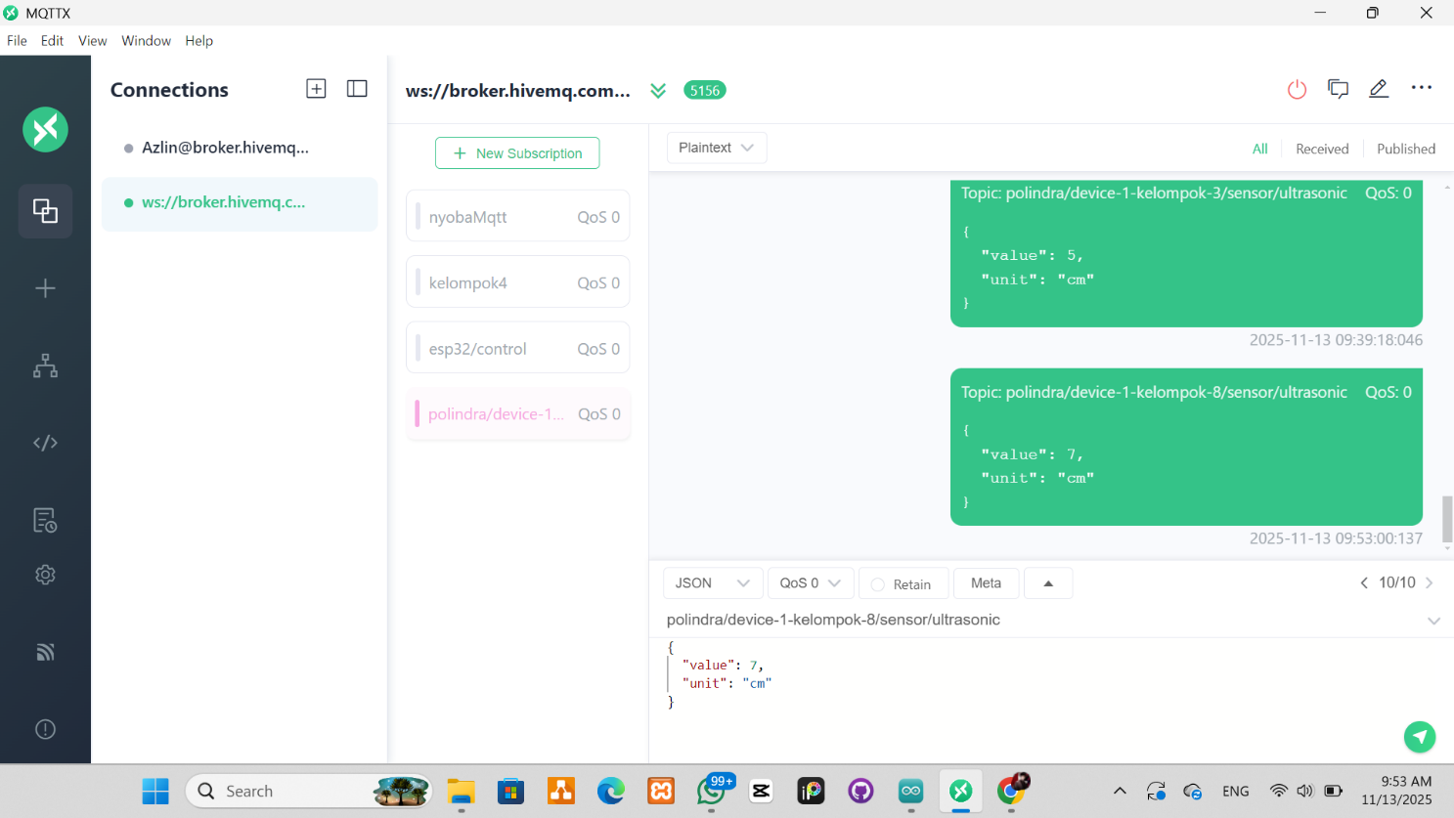

MQTT mengirimkan data ke web iot

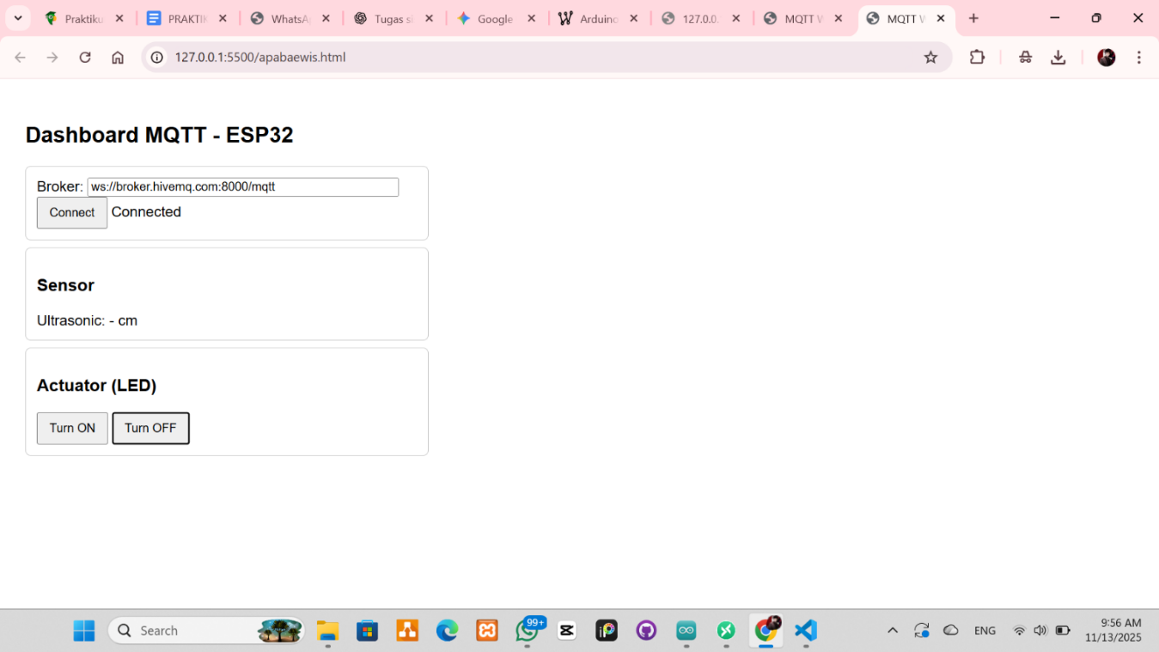

Tampilan awal web iot

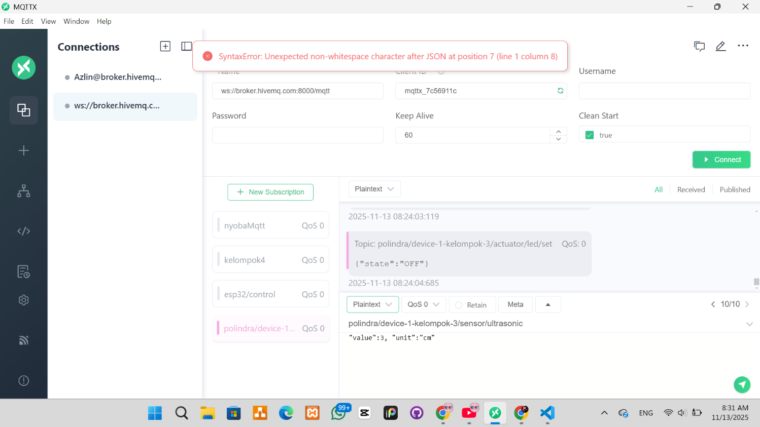

Salah menginputkan data

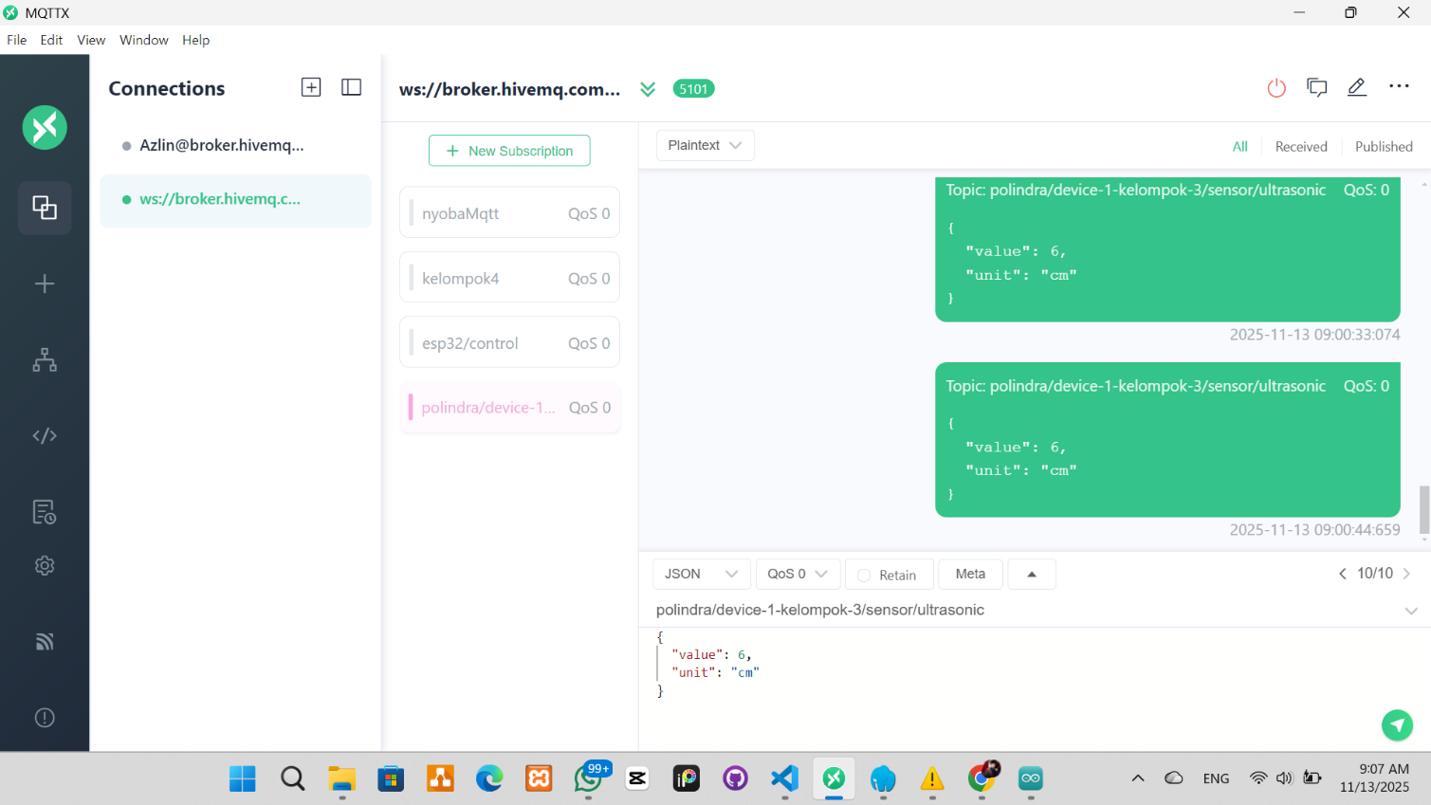

Input data berhasil terkirim ke web iot

<!doctype html>
<html>
<head>
<meta charset="utf-8" />
<title>MQTT Web Dashboard</title>
<script src="https://unpkg.com/mqtt/dist/mqtt.min.js"></script>
<style>
body {
font-family: Arial, sans-serif;
padding: 20px;
}
.card {
border: 1px solid #ccc;
padding: 12px;
margin: 8px 0;
border-radius: 6px;
max-width: 420px;
}
button {
padding: 8px 12px;
}
</style>
</head>
<body>
<h2>Dashboard MQTT - ESP32</h2>
<div class="card">
<div>Broker: <input id="broker" value="ws://broker.hivemq.com:8000/mqtt" style="width:80%"></div>
<div><button id="connectBtn">Connect</button> <span id="connStatus">Disconnected</span></div>
</div>
<div class="card">
<h3>Sensor</h3>
<div>Ultrasonic: <span id="ultrasonic">-</span> cm</div>
</div>
<div class="card">
<h3>Actuator (LED)</h3>
<button id="ledOnBtn">Turn ON</button>
<button id="ledOffBtn">Turn OFF</button>
</div>
<script>
let client = null;
const deviceId = "device-1-kelompok-3";
const topics = {
ultrasonic: `polindra/${deviceId}/sensor/ultrasonic`,
ledSet: `polindra/${deviceId}/actuator/led/set`
};
function connect(brokerUrl) {
client = mqtt.connect(brokerUrl);
document.getElementById('connStatus').innerText = 'Connecting...';
client.on('connect', () => {
document.getElementById('connStatus').innerText = 'Connected';
client.subscribe(topics.ultrasonic);
});
client.on('message', (topic, payload) => {
try {
const msg = JSON.parse(payload.toString());
if (topic === topics.ultrasonic) {
document.getElementById('ultrasonic').innerText = msg.value;
} else if (topic === topics.lainnya) {
// silakan tambahkan logika untuk topic lainnya
}
} catch (e) {
console.log('Invalid JSON', payload.toString());
}
});
client.on('error', (err) => {
console.error(err);
document.getElementById('connStatus').innerText = 'Error';
});
client.on('close', () => {
document.getElementById('connStatus').innerText = 'Disconnected';
});
}
document.getElementById('connectBtn').addEventListener('click', () => {
const url = document.getElementById('broker').value;
connect(url);
});
document.getElementById('ledOnBtn').addEventListener('click', () => {
if (client && client.connected) {
client.publish(topics.ledSet, JSON.stringify({ state: "ON" }));
}
});
document.getElementById('ledOffBtn').addEventListener('click', () => {
if (client && client.connected) {
client.publish(topics.ledSet, JSON.stringify({ state: "OFF" }));
}
});
</script>
</body>
</html>

Kode program web iot

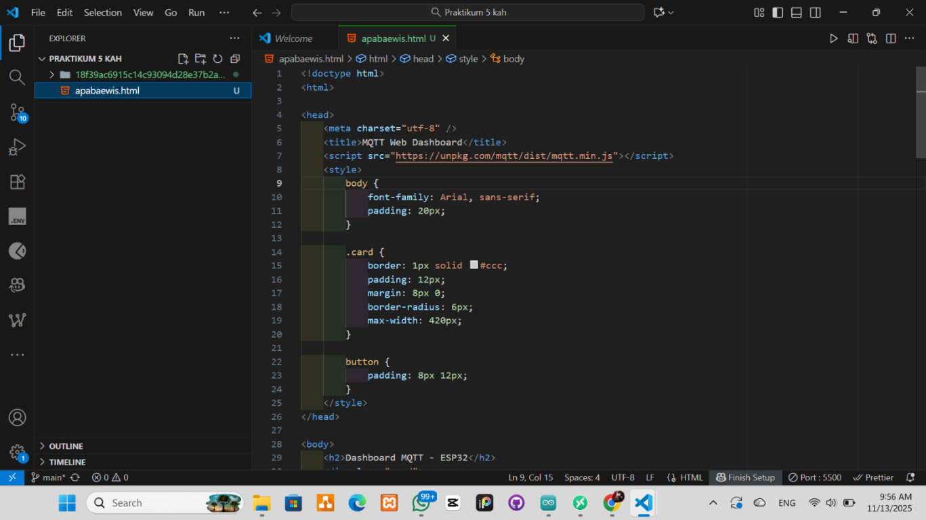

Kode program di VSCode

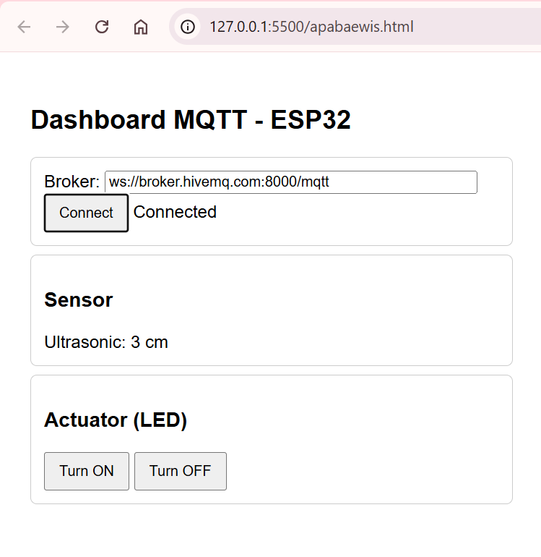

Tampilan web iot ketika berhasil menerima data dari MQTT

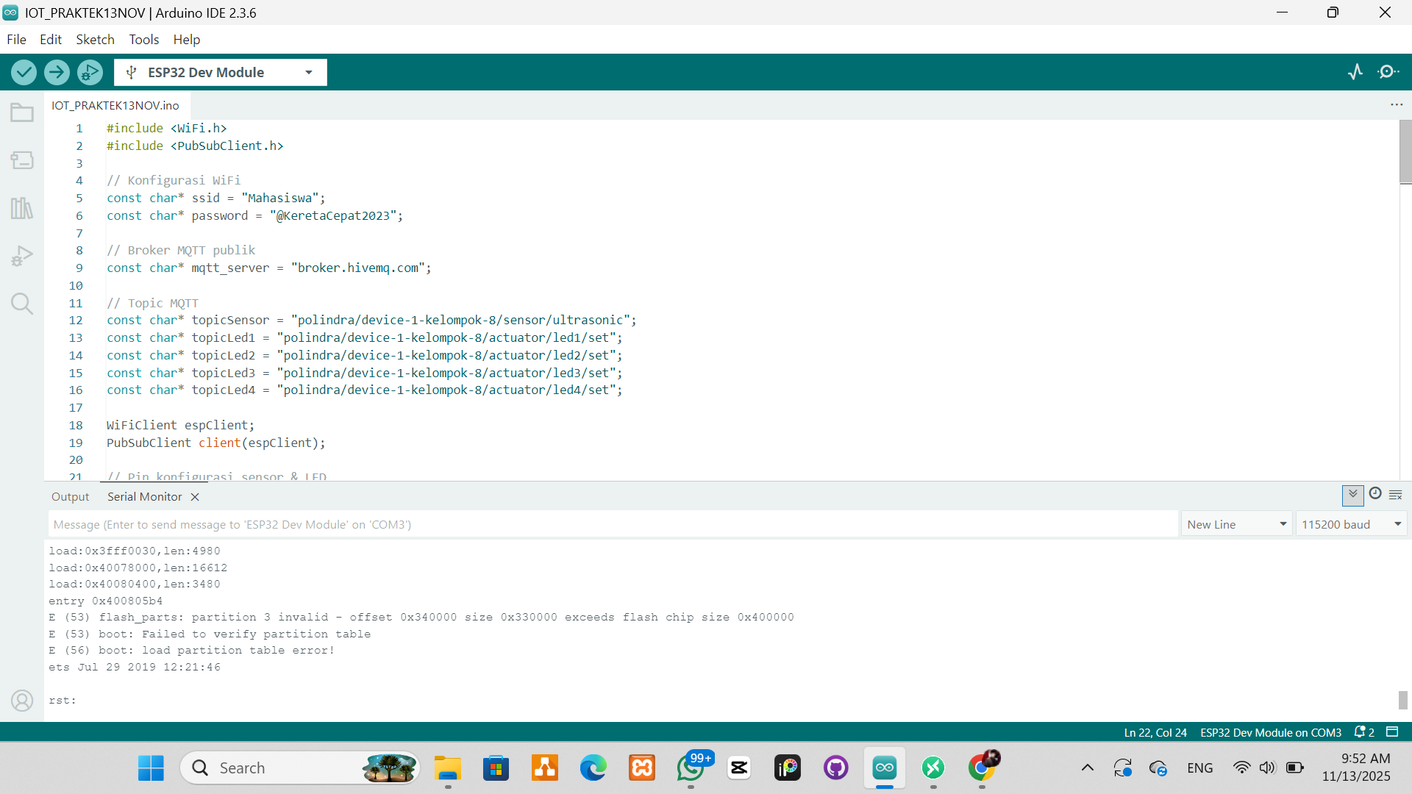
Mencoba menghubungkan perangkat iot dengan web iot, namun masih gagal.

